**1. nano**

‘nano’ is a the simple terminal-based text editor. It is a simpe and user-friendly command-line text editor .

We can install nano by using package manager . for example on, Debian/ubuntu systems we use:-

**sudo apt-get install nano**

Here, the example of nano screen layout:-

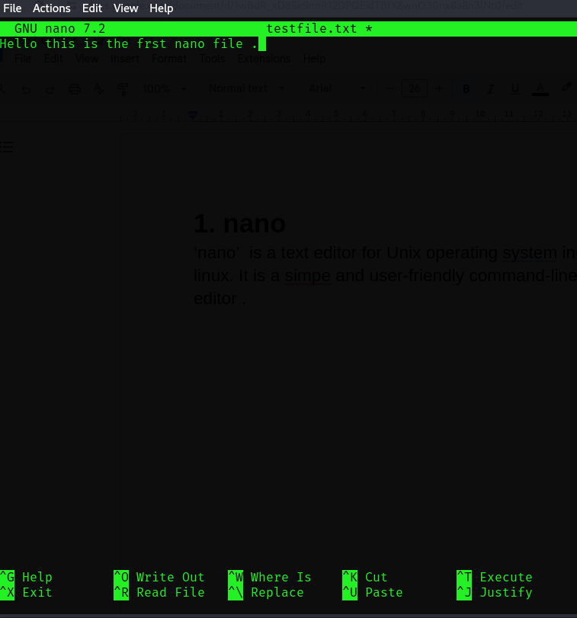

Here the process of navigating nano editor:-

* ctrl + G to display the help menu
* ctrl + O to save the file.
* ctrl + R to read a new file.
* Ctrl + W to search for a string.
* Ctrl + K to cut a line.
* Ctrl + U to paste a cut line.
* ctrl + x to exit nano.

**2 .vim**

vim is a highly configurable text editor built to make creating and changing any kind of text very efficient. It is included as "vi" with most UNIX systems .

We can install nano by using package manager . for example on, Debian/ubuntu systems we use:-

**sudo apt-get install vim**

Here, the screen layout of vim:-

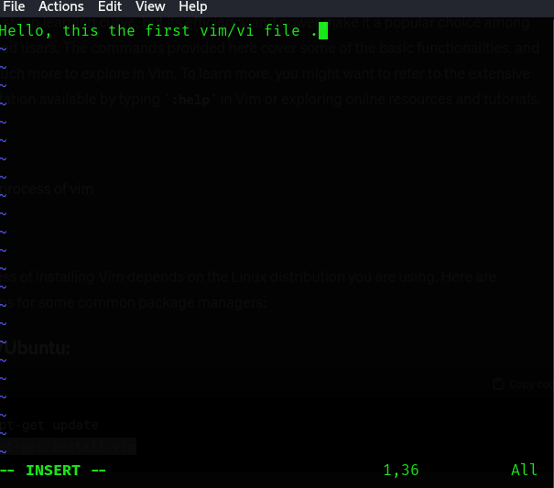

There are two modes in vim:-

* Normal mode (command mode)
* Insert mode
* Normal mode:-

a). We need to use arrow keys to move the cursor.

b). ‘h’,’j’,’k’,’l’ for left, down ,up and right respectively.

c). ‘gg’ is used to go to the beginning of the file.

d). ‘G’ is used to go to the end of the file.

e). ‘:set number’ is used to display line numbers.

* Insert mode:-

a). ‘I’ to enter into the insert mode before cursor.

b). ‘r’ to enter into the insert mode at the beginning of the line.

c). ‘a’ to enter insert mode after the cursor.  
d.) ‘A’ to enter insert mode at the end of the line.

* saving and exiting:

a). ‘:q’ to quit vim.

b). ‘:wq’ to save changes and quit vim.

c). ‘:q!’ to quit without saving changes in vim.